PO Tracker
Purchase Order (PO) Process Flow
If a request is Within Budget
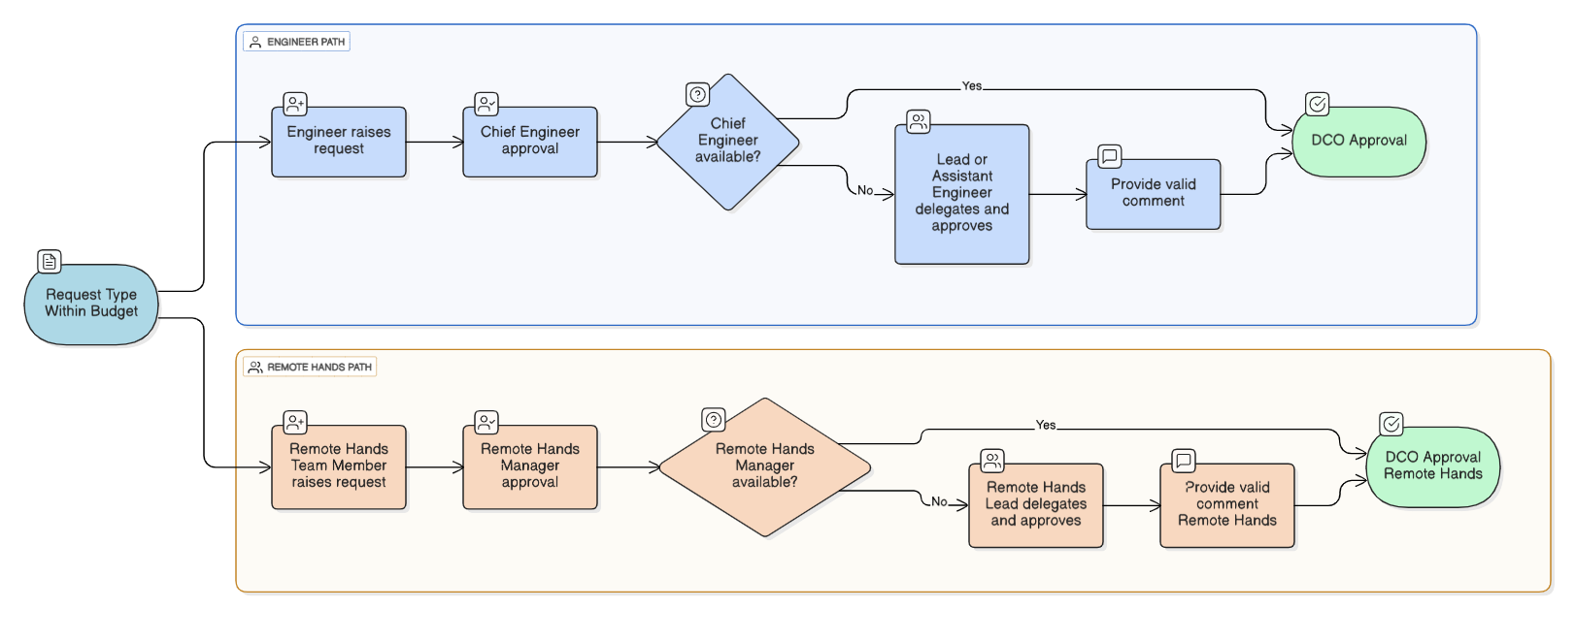

If a request is Over Budget
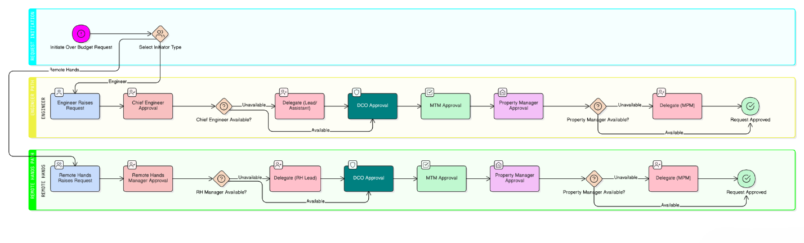
Note:
- Every delegation must include a clear and valid comment.
- Upon rejection, the requestor and previously approvers will receive a notification with the rejection comments.

PO Creation & Handling
Once approval is completed:
- Property Assistant raises the PO number in the system.
- Timeline: PO must appear within 3 days of DCO approval.
- If PO is not visible within the timeline → Escalation process begins.
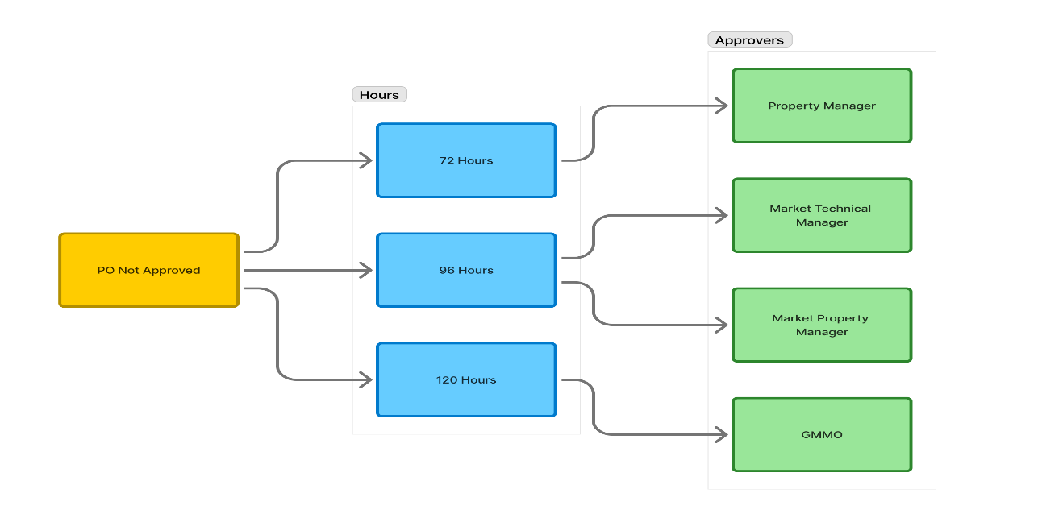

Escalation Path (If PO Not Approved / Created)
Time After DCO Approval | Escalation Level | Action
72 hours | PM | Follow-up initiated
96 hours | MPM & MTM | Escalation email/alert
120 hours | GMMO | Final escalation

End of Process
The PO request lifecycle is complete after:
- All required approvals are received
- PO is created and verified in system

Budget Transfer

IUP Budget Handling
- If IUP number is present, budget must be allocated from GL codes starting with 1.

Budget Transfer Rules
- GL codes starting with 1 → Transfers allowed across all site codes.
- GL codes starting with 4 → Transfers allowed within same site code.
- If “Unbudgeted” is selected: Transfers can be made from IUP to IUP.

Budget Allocation
- Allocate budget to GL per site.
Version History
- Maintains a lot of all budget changes with version-wise details for tracking and audit purposes.

GL Code Configuration
- Configure GL Codes

